Федеральное государственное образовательное бюджетное учреждение

высшего образования

«Финансовый университет

при Правительстве Российской Федерации»

Департамент информационных технологий и анализа больших данных

Практическая работа по дисциплине «Организация вычислительных систем»

Выполнил:

Студент группы ПИ21-2

Преснухин Дмитрий

________________

Проверил:

Петросов Д. А.

Выполнение: ____________

Защита: ____________

Москва 2022

# Оглавление

Оглавление 2

Задание №1 3

Задание №2 6

Задание №4 7

Код: 7

Примеры работы программы: 8

Задание № 5 8

Код: 8

Примеры работы программы: 9

Задание № 6 9

Код: 10

Примеры работы программы: 12

Выыод 14

Дублирую задания №1 и №2, т.к. изначально писал их от руки: 14

Задание №1

Выполните ручной перевод IP-адресов, представленных десятичной записью в двоичную, а двоичные в десятичную:

1. 10.124.56.220

|  |  |  |  |  |  |  |  |
| --- | --- | --- | --- | --- | --- | --- | --- |
| 128 | 64 | 32 | 16 | 8 | 4 | 2 | 1 |
| 0 | 0 | 0 | 0 | 1 | 0 | 1 | 0 |

|  |  |  |  |  |  |  |  |
| --- | --- | --- | --- | --- | --- | --- | --- |
| 128 | 64 | 32 | 16 | 8 | 4 | 2 | 1 |
| 0 | 1 | 1 | 1 | 1 | 1 | 0 | 0 |

|  |  |  |  |  |  |  |  |
| --- | --- | --- | --- | --- | --- | --- | --- |
| 128 | 64 | 32 | 16 | 8 | 4 | 2 | 1 |
| 0 | 0 | 1 | 1 | 1 | 0 | 0 | 0 |

|  |  |  |  |  |  |  |  |
| --- | --- | --- | --- | --- | --- | --- | --- |
| 128 | 64 | 32 | 16 | 8 | 4 | 2 | 1 |
| 1 | 1 | 0 | 1 | 1 | 1 | 0 | 0 |

**Ответ**: 00001010.01111100.00111000.11011100

2) 113.72.101.11

|  |  |  |  |  |  |  |  |
| --- | --- | --- | --- | --- | --- | --- | --- |
| 128 | 64 | 32 | 16 | 8 | 4 | 2 | 1 |
| 0 | 1 | 1 | 1 | 0 | 0 | 0 | 1 |

|  |  |  |  |  |  |  |  |
| --- | --- | --- | --- | --- | --- | --- | --- |
| 128 | 64 | 32 | 16 | 8 | 4 | 2 | 1 |
| 0 | 1 | 0 | 0 | 1 | 0 | 0 | 0 |

|  |  |  |  |  |  |  |  |
| --- | --- | --- | --- | --- | --- | --- | --- |
| 128 | 64 | 32 | 16 | 8 | 4 | 2 | 1 |
| 0 | 1 | 1 | 0 | 0 | 1 | 0 | 1 |

|  |  |  |  |  |  |  |  |
| --- | --- | --- | --- | --- | --- | --- | --- |
| 128 | 64 | 32 | 16 | 8 | 4 | 2 | 1 |
| 0 | 0 | 0 | 0 | 1 | 0 | 1 | 1 |

**Ответ**: 01110001.01001000.01100101.00001011

3) 173.143.32.194

|  |  |  |  |  |  |  |  |
| --- | --- | --- | --- | --- | --- | --- | --- |
| 128 | 64 | 32 | 16 | 8 | 4 | 2 | 1 |
| 1 | 0 | 1 | 0 | 1 | 1 | 0 | 1 |

|  |  |  |  |  |  |  |  |
| --- | --- | --- | --- | --- | --- | --- | --- |
| 128 | 64 | 32 | 16 | 8 | 4 | 2 | 1 |
| 1 | 0 | 0 | 0 | 1 | 1 | 1 | 1 |

|  |  |  |  |  |  |  |  |
| --- | --- | --- | --- | --- | --- | --- | --- |
| 128 | 64 | 32 | 16 | 8 | 4 | 2 | 1 |
| 0 | 0 | 1 | 0 | 0 | 0 | 0 | 0 |

|  |  |  |  |  |  |  |  |
| --- | --- | --- | --- | --- | --- | --- | --- |
| 128 | 64 | 32 | 16 | 8 | 4 | 2 | 1 |
| 1 | 1 | 0 | 0 | 0 | 0 | 1 | 0 |

**Ответ**: 10101101.10001111.00100000.11000010

4) 200.69.139.217

|  |  |  |  |  |  |  |  |
| --- | --- | --- | --- | --- | --- | --- | --- |
| 128 | 64 | 32 | 16 | 8 | 4 | 2 | 1 |
| 1 | 1 | 0 | 0 | 1 | 0 | 0 | 0 |

|  |  |  |  |  |  |  |  |
| --- | --- | --- | --- | --- | --- | --- | --- |
| 128 | 64 | 32 | 16 | 8 | 4 | 2 | 1 |
| 0 | 1 | 0 | 0 | 0 | 1 | 0 | 1 |

|  |  |  |  |  |  |  |  |
| --- | --- | --- | --- | --- | --- | --- | --- |
| 128 | 64 | 32 | 16 | 8 | 4 | 2 | 1 |
| 1 | 0 | 0 | 0 | 1 | 0 | 1 | 1 |

|  |  |  |  |  |  |  |  |
| --- | --- | --- | --- | --- | --- | --- | --- |
| 128 | 64 | 32 | 16 | 8 | 4 | 2 | 1 |
| 1 | 1 | 0 | 1 | 1 | 0 | 0 | 1 |

**Ответ**: 11001000.01000101.10001011.11011001

5) 88.212.236.76

|  |  |  |  |  |  |  |  |
| --- | --- | --- | --- | --- | --- | --- | --- |
| 128 | 64 | 32 | 16 | 8 | 4 | 2 | 1 |
| 0 | 1 | 0 | 1 | 1 | 0 | 0 | 0 |

|  |  |  |  |  |  |  |  |
| --- | --- | --- | --- | --- | --- | --- | --- |
| 128 | 64 | 32 | 16 | 8 | 4 | 2 | 1 |
| 1 | 1 | 0 | 1 | 0 | 1 | 0 | 0 |

|  |  |  |  |  |  |  |  |
| --- | --- | --- | --- | --- | --- | --- | --- |
| 128 | 64 | 32 | 16 | 8 | 4 | 2 | 1 |
| 1 | 1 | 1 | 0 | 1 | 1 | 0 | 0 |

|  |  |  |  |  |  |  |  |
| --- | --- | --- | --- | --- | --- | --- | --- |
| 128 | 64 | 32 | 16 | 8 | 4 | 2 | 1 |
| 0 | 1 | 0 | 0 | 1 | 1 | 0 | 0 |

**Ответ**: 01011000.11010100.11101100.01001100

6) 01011101.10111011.01001000.00110000

|  |  |  |  |  |  |  |  |
| --- | --- | --- | --- | --- | --- | --- | --- |
| 128 | 64 | 32 | 16 | 8 | 4 | 2 | 1 |
| 0 | 1 | 0 | 1 | 1 | 1 | 0 | 1 |

|  |  |  |  |  |  |  |  |
| --- | --- | --- | --- | --- | --- | --- | --- |
| 128 | 64 | 32 | 16 | 8 | 4 | 2 | 1 |
| 1 | 0 | 1 | 1 | 1 | 0 | 1 | 1 |

|  |  |  |  |  |  |  |  |
| --- | --- | --- | --- | --- | --- | --- | --- |
| 128 | 64 | 32 | 16 | 8 | 4 | 2 | 1 |
| 0 | 1 | 0 | 0 | 1 | 0 | 0 | 0 |

|  |  |  |  |  |  |  |  |
| --- | --- | --- | --- | --- | --- | --- | --- |
| 128 | 64 | 32 | 16 | 8 | 4 | 2 | 1 |
| 0 | 0 | 1 | 1 | 0 | 0 | 0 | 0 |

**Ответ**: 93.187.72.48

7) 01001000.10100011.00000100.10100001

|  |  |  |  |  |  |  |  |
| --- | --- | --- | --- | --- | --- | --- | --- |
| 128 | 64 | 32 | 16 | 8 | 4 | 2 | 1 |
| 0 | 1 | 0 | 0 | 1 | 0 | 0 | 0 |

|  |  |  |  |  |  |  |  |
| --- | --- | --- | --- | --- | --- | --- | --- |
| 128 | 64 | 32 | 16 | 8 | 4 | 2 | 1 |
| 1 | 0 | 1 | 0 | 0 | 0 | 1 | 1 |

|  |  |  |  |  |  |  |  |
| --- | --- | --- | --- | --- | --- | --- | --- |
| 128 | 64 | 32 | 16 | 8 | 4 | 2 | 1 |
| 0 | 0 | 0 | 0 | 0 | 1 | 0 | 0 |

|  |  |  |  |  |  |  |  |
| --- | --- | --- | --- | --- | --- | --- | --- |
| 128 | 64 | 32 | 16 | 8 | 4 | 2 | 1 |
| 1 | 0 | 1 | 0 | 0 | 0 | 0 | 1 |

**Ответ**: 72.163.4.161

8) 00001111.11011001.11101000.11110101

|  |  |  |  |  |  |  |  |
| --- | --- | --- | --- | --- | --- | --- | --- |
| 128 | 64 | 32 | 16 | 8 | 4 | 2 | 1 |
| 0 | 0 | 0 | 0 | 1 | 1 | 1 | 1 |

|  |  |  |  |  |  |  |  |
| --- | --- | --- | --- | --- | --- | --- | --- |
| 128 | 64 | 32 | 16 | 8 | 4 | 2 | 1 |
| 1 | 1 | 0 | 1 | 1 | 0 | 0 | 1 |

|  |  |  |  |  |  |  |  |
| --- | --- | --- | --- | --- | --- | --- | --- |
| 128 | 64 | 32 | 16 | 8 | 4 | 2 | 1 |
| 1 | 1 | 1 | 0 | 1 | 0 | 0 | 0 |

|  |  |  |  |  |  |  |  |
| --- | --- | --- | --- | --- | --- | --- | --- |
| 128 | 64 | 32 | 16 | 8 | 4 | 2 | 1 |
| 1 | 1 | 1 | 1 | 0 | 1 | 0 | 1 |

**Ответ**: 15.217.232.245

9) 01000101.00010100.00111011.01010000

|  |  |  |  |  |  |  |  |
| --- | --- | --- | --- | --- | --- | --- | --- |
| 128 | 64 | 32 | 16 | 8 | 4 | 2 | 1 |
| 0 | 1 | 0 | 0 | 0 | 1 | 0 | 1 |

|  |  |  |  |  |  |  |  |
| --- | --- | --- | --- | --- | --- | --- | --- |
| 128 | 64 | 32 | 16 | 8 | 4 | 2 | 1 |
| 0 | 0 | 0 | 1 | 0 | 1 | 0 | 0 |

|  |  |  |  |  |  |  |  |
| --- | --- | --- | --- | --- | --- | --- | --- |
| 128 | 64 | 32 | 16 | 8 | 4 | 2 | 1 |
| 0 | 0 | 1 | 1 | 1 | 0 | 1 | 1 |

|  |  |  |  |  |  |  |  |
| --- | --- | --- | --- | --- | --- | --- | --- |
| 128 | 64 | 32 | 16 | 8 | 4 | 2 | 1 |
| 0 | 1 | 0 | 1 | 0 | 0 | 0 | 0 |

**Ответ**: 69.20.59.80

10) 00101011.11110011.10000010.00111101

|  |  |  |  |  |  |  |  |
| --- | --- | --- | --- | --- | --- | --- | --- |
| 128 | 64 | 32 | 16 | 8 | 4 | 2 | 1 |
| 0 | 0 | 1 | 0 | 1 | 0 | 1 | 1 |

|  |  |  |  |  |  |  |  |
| --- | --- | --- | --- | --- | --- | --- | --- |
| 128 | 64 | 32 | 16 | 8 | 4 | 2 | 1 |
| 1 | 1 | 1 | 1 | 0 | 0 | 1 | 1 |

|  |  |  |  |  |  |  |  |
| --- | --- | --- | --- | --- | --- | --- | --- |
| 128 | 64 | 32 | 16 | 8 | 4 | 2 | 1 |
| 1 | 0 | 0 | 0 | 0 | 0 | 1 | 0 |

|  |  |  |  |  |  |  |  |
| --- | --- | --- | --- | --- | --- | --- | --- |
| 128 | 64 | 32 | 16 | 8 | 4 | 2 | 1 |
| 0 | 0 | 1 | 1 | 1 | 1 | 0 | 1 |

**Ответ**: 43.243.130.61

Задание №2

1) Записать маску для проекта: сеть 172.16.0.0. 250 подсетей и 220 хостов

Класс B → N = 16

Подсетей 250 <= 28 (S >= 8)

Хостов 220 <= 28 – 2 (H >= 8)

N + S + H = 32

H <= 32 - 16 - 8 = 8

H <= 8 and H >= 8 → H = 8, S = 8

16 + 8 = 24 → маска: 255.255.255.0

**Ответ**: 255.255.255.0

2) Записать маску для проекта: сеть 10.0.0.0. 2000 подсетей и 1500 хостов

Класс A → N = 8

Подсетей 2200 <= 211 (S >= 11)

Хостов 1500 <= 211 – 2 (H >= 11)

N + S + H = 32

H <= 32 - 8 - 11 = 13

H <= 13 and H >= 11 → (H = 13, S = 11) or (H = 12, S = 12) or (H = 11, S = 13)

1. 8 + 11 = 19 → маска: 255.255.224.0
2. 8 + 12 = 20 → маска: 255.255.240.0
3. 8 + 13 = 21 → маска: 255.255.248.0

**Ответ**: 255.255.224.0, 255.255.240.0, 255.255.248.0

3) Записать маску для проекта: сеть 192.168.0.0. 4 подсети и 60 хостов

Класс С → N = 24

Подсетей 4 <= 22 (S >= 2)

Хостов 60 <= 26 – 2 (H >= 6)

N + S + H = 32

H <= 32 - 24 - 2 = 6

H = 6, S = 2

24 + 2 = 26 → маска: 255.255.255.192

**Ответ**: 255.255.255.192

Задание №4

Реализовать программное средство для представления IP адресов с десятичного и двоичного кодирования. В качестве входных данных задается десятичное представление IP адреса, программное средство выдает двоичное представление или пользователь может ввести двоичное представление IP адреса и получить десятичное представление.

### Код:

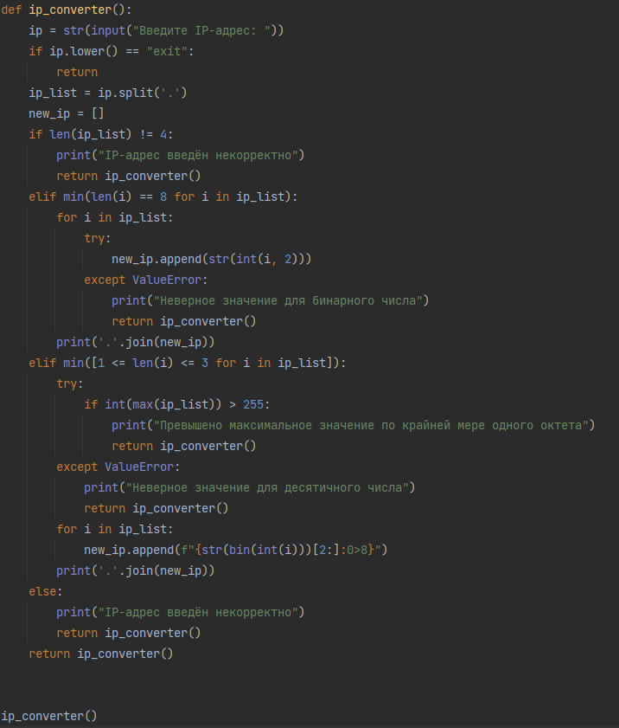

### Примеры работы программы:

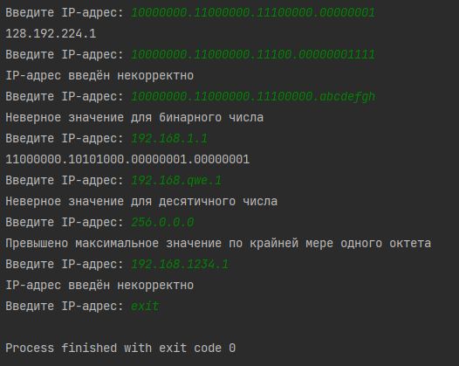

Задание № 5

Реализовать программное средство, способное определять класс сети, начальный и конечный адрес и маску подсети, на основании заданного IP адреса.

### Код:

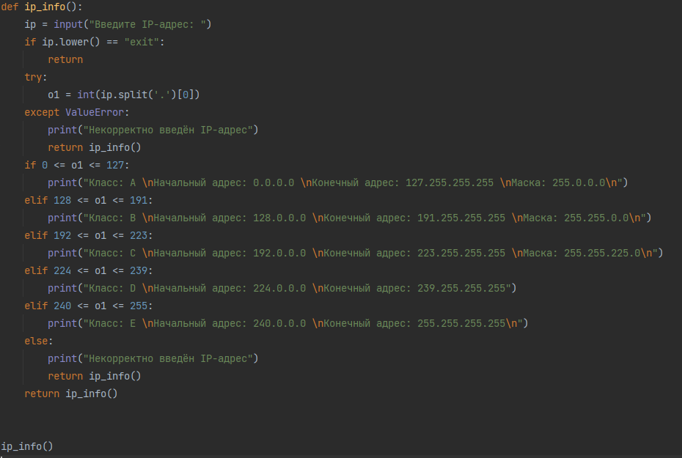

### Примеры работы программы:

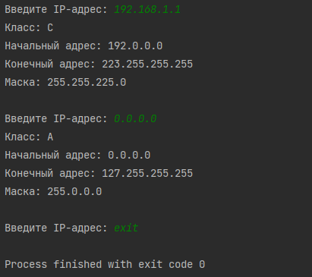

Задание № 6

Разработать программное средство, которое по заданной сети, количеству подсетей и хостов формирует: маску для проекта сети, а также определяет класс сетей, начало и конец сети, количество IP-адресов в сети, количество доступных IP-адресов в сети для назначения хостам, стек первых 5 допустимых IP-адресов, стек последних 5 допустимых IP-адресов.

### Код:

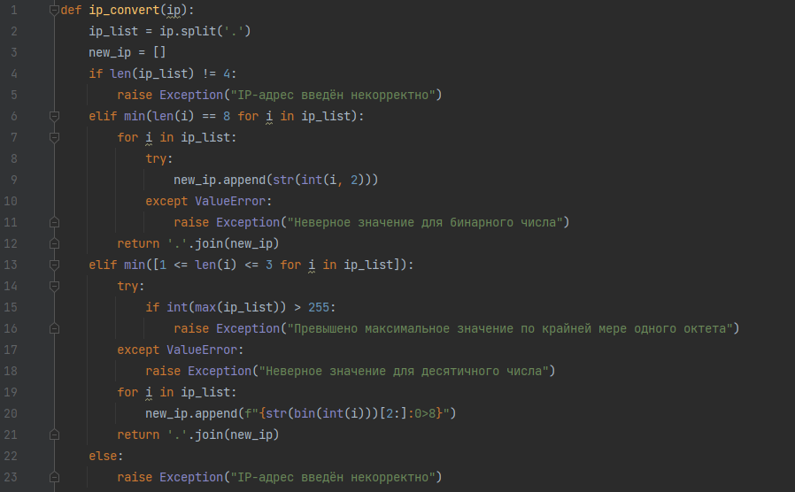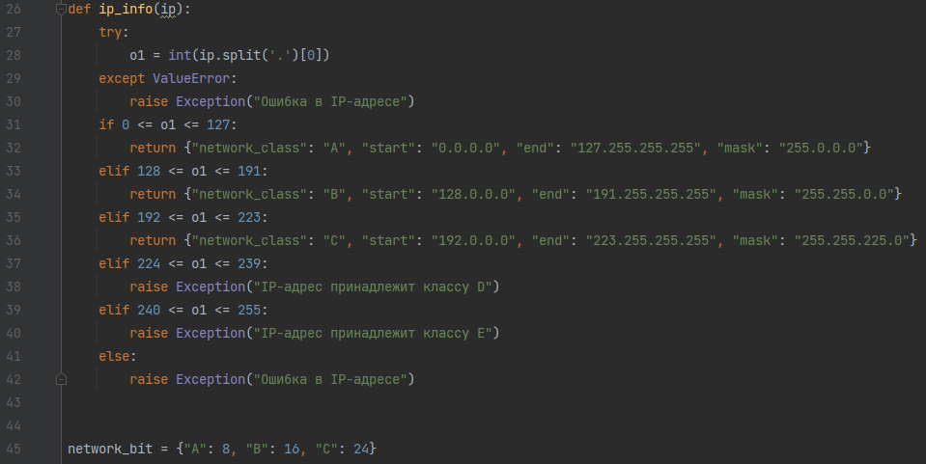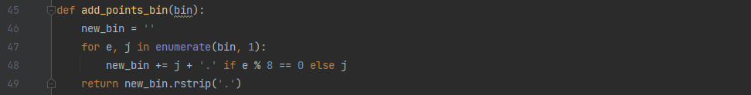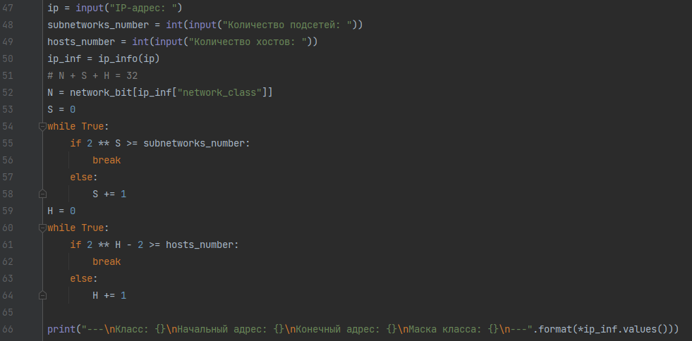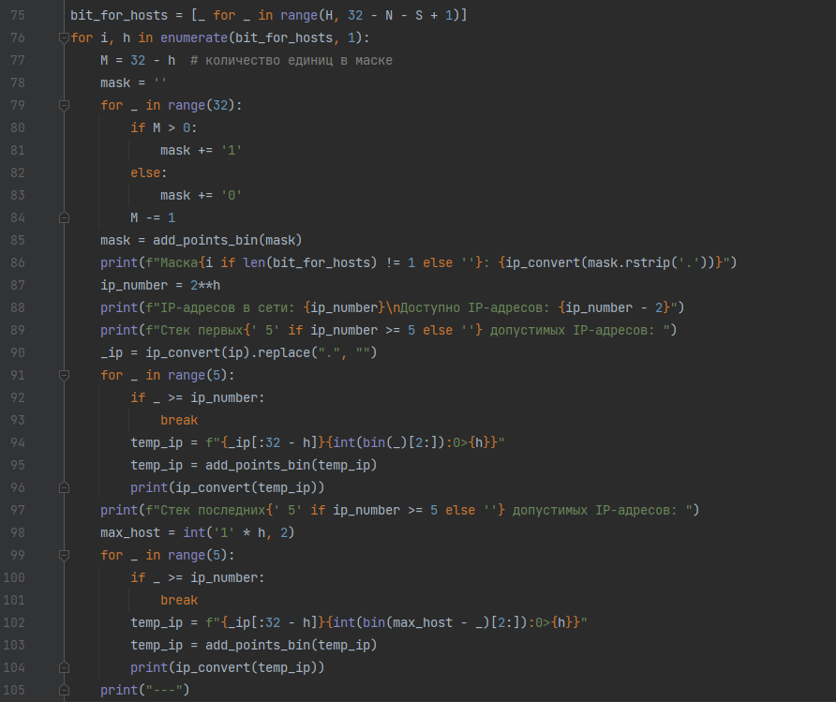

### Примеры работы программы:

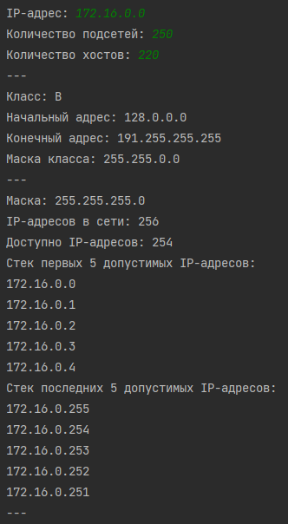

Продолжение ↓

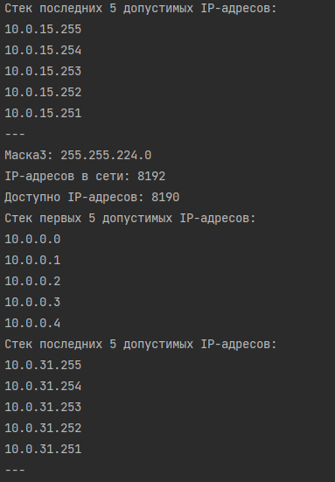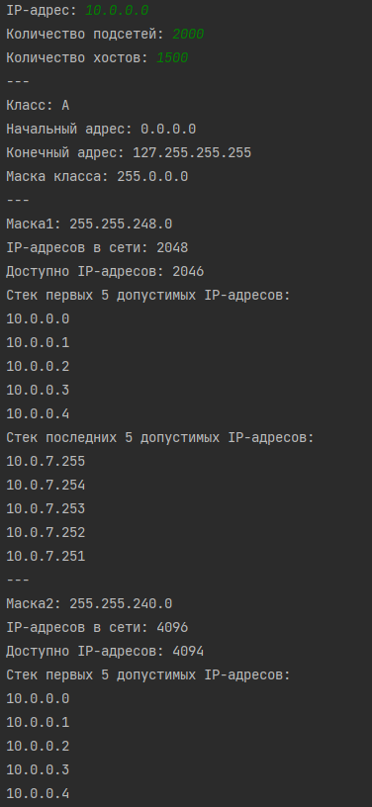

# Выыод

В ходе работы были приобретены навыки по работе с IP адресами и масками, получены дополнительные знания о зависимости количества подсетей и хостов от маски подсети. Теоретический материал был подкреплен практической работой, требующей навыки программирования на языке Python.

# Дублирую задания №1 и №2, т.к. изначально писал их от руки:

